(iv) Database Implementation
Created a SQL Server database named "StudentManagement" with two tables:

Courses Table:
Sql:-
CREATE TABLE Courses (
CourseId INT PRIMARY KEY IDENTITY(1,1),
Name NVARCHAR(100) NOT NULL,
LecturerName NVARCHAR(100) NOT NULL
);

Students Table:
Sql:-
CREATE TABLE Students (
StudentId INT PRIMARY KEY IDENTITY(1,1),
Name NVARCHAR(100) NOT NULL,
City NVARCHAR(50) NOT NULL,
CourseId INT FOREIGN KEY REFERENCES Courses(CourseId)

Sample Data Insertion
Sql:-
-- Insert courses
INSERT INTO Courses (Name, LecturerName) VALUES
('Web Development', 'M.M. Herath'),
('Graphic Design', 'J.S.V. Piyasena'),
('Mobile App Development', 'K.K.S. Dias'),
('Java', 'U.H.S. Perera');

-- Insert students
INSERT INTO Students (Name, City, CourseId) VALUES
('Kasun Gamage', 'Kandy', 2),
('Daniel Sam', 'Jaffna', 3),
('Hansi Silva', 'Colombo', 1),
('Ranidu Heath', 'Matara', 3),
('Praneeth Wijesinghe', 'Kandy', 4),
('Nuwani Herath', 'Rathnapura', 1);

II. SQL Queries
A. Get all the information of all Students

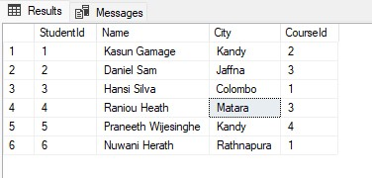
SELECT * FROM Students;

B. Select student id, name and city from students who are from 'Kandy'

SELECT StudentId, Name, City
FROM Students
WHERE City = 'Kandy';


C. Update the City as 'Galle' of the student whose id equals to 4

UPDATE Students
SET City = 'Galle'
WHERE StudentId = 4;

Verification
SELECT StudentId, Name, City
FROM Students
WHERE StudentId = 4;


D. Get all the information of all students with their course names

SELECT s.StudentId, s.Name AS StudentName, s.City,
c.CourseId, c.Name AS CourseName, c.LecturerName
FROM Students s
JOIN Courses c ON s.CourseId = c.CourseId;
